OUTPUT:
Data loading: Placeholder data used. Ensure to replace with actual finance data.

--- Q1 (Category 5): LDA Model Training and Evaluation (TM A) ---
LDA Model Accuracy: 0.3033
LDA Confusion Matrix:
[[22 50 28]
[30 46 25]
[24 52 23]]
LDA Feature Coefficients (First Discriminant, Standardized Data):
RSI_14: 0.0446
MACD_Signal: -0.0084
Vol_Index: -0.0561
Momentum: -0.0160
Market_Breadth: -0.0205
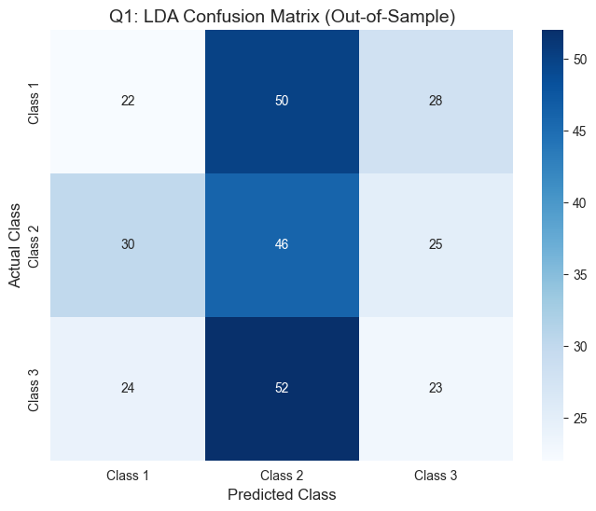

--- Q2 (Category 6): SVM Model Training and Evaluation (TM B) ---
Optimal SVM Hyperparameters: {'C': 1, 'kernel': 'linear'}
Optimal SVM Model Accuracy: 0.3133
Optimal SVM Classification Report (F1-Score, etc.):
precision recall f1-score support

1 0.29 0.24 0.26 100
2 0.32 0.46 0.38 101
3 0.32 0.24 0.28 99

accuracy 0.31 300
macro avg 0.31 0.31 0.31 300
weighted avg 0.31 0.31 0.31 300

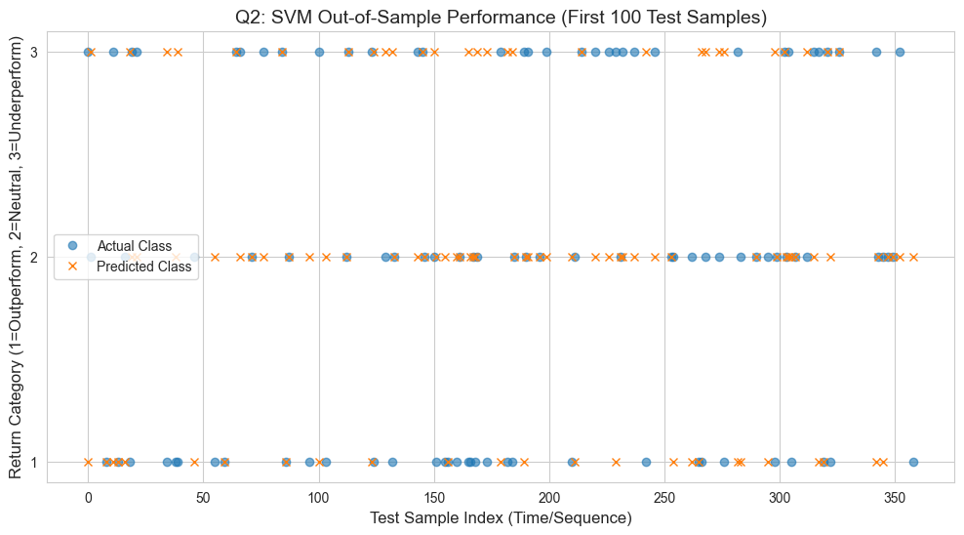

--- Q3 (Category 7): Neural Network Model Training and Evaluation (TM C) ---
FNN Model Test Accuracy: 0.3367
FNN Model Test Loss: 1.1872
10/10 [==============================] - 0s 1ms/step
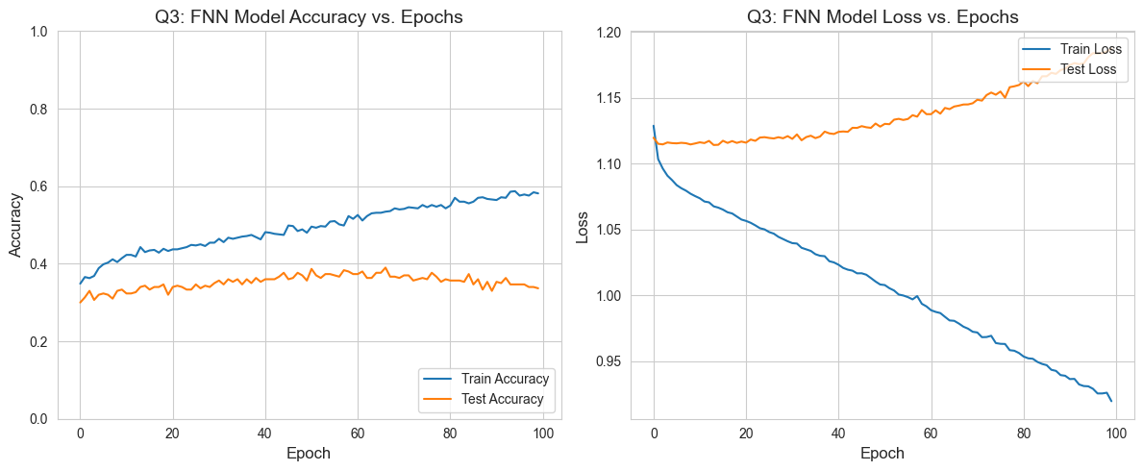
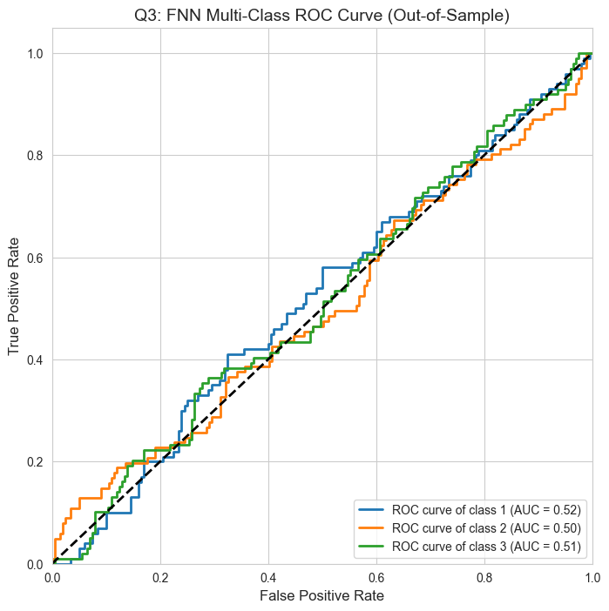

--- All Quantitative Analysis computations complete. ---

